Project Design Phase-II
Technology Stack (Architecture & Stack)
Date | 30 September 2026
Team ID | SWTID-2026-4970
Project Name | Import Data using Transform Maps (Spreadsheet)
Maximum Marks | 4 Marks
Technical Architecture:
The Deliverable shall include the architectural diagram as below and the information as per the table1 & table 2
Architecture flow for this project:
- The employee data is created in Google Sheets and downloaded as Sample Spreadsheet.xlsx.
- The file is uploaded to ServiceNow through System Import Sets > Load Data and stored in the Import Set (staging) table Employee Import (u_employee_import).
- The Transform Map “Sample Spreadsheet Import” maps the staged fields to the target table Employee Test (u_employee_test).
- Coalesce on Employee ID decides whether each record is inserted, updated or ignored.
- Transform History and the Import Log are used to verify the result of every load.
- Reports (pie, bar, list) are built on the target table and shown on the Employee Analytics Dashboard.
Example: Import Data using Transform Maps (Spreadsheet)
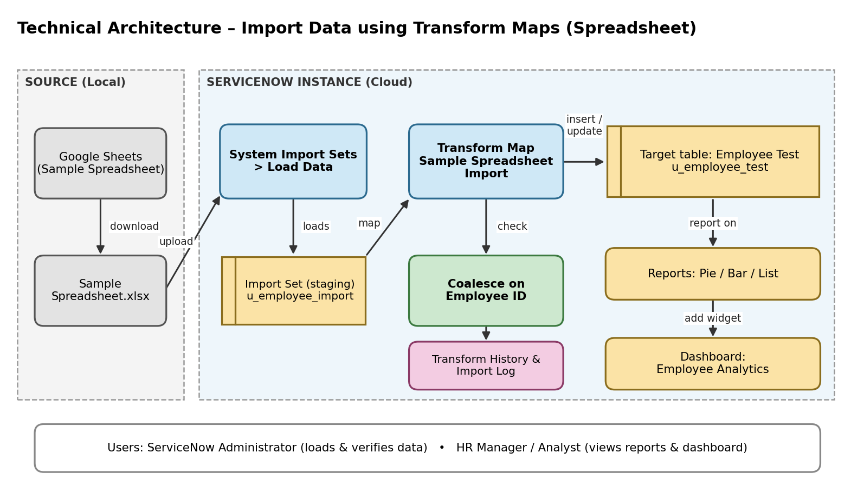
Table-1 : Components & Technologies:
S.No | Component | Description | Technology
1. | User Interface | How the user interacts with the application: ServiceNow web UI (Application Navigator, forms, list views, Reports and Dashboards) and Google Sheets for the source data | ServiceNow web UI (browser), Google Sheets
2. | Application Logic-1 (Data Import) | Loads the spreadsheet rows into a staging table before any change is made to real data | ServiceNow System Import Sets – Load Data, Import Set table u_employee_import
3. | Application Logic-2 (Transformation) | Maps source fields to target fields and creates the records in the target table | ServiceNow Transform Map “Sample Spreadsheet Import”, Auto Map Matching Fields / Mapping Assist
4. | Application Logic-3 (Duplicate Check) | Prevents duplicate employees by updating a record when the Employee ID already exists | Coalesce on Employee ID (field map)
5. | Database | Custom target table with five String fields: Employee ID, Employee Name, Email, Department, Location | ServiceNow platform database – table u_employee_test
6. | Cloud Database | Database service on the cloud: all tables are hosted by the ServiceNow instance | ServiceNow cloud instance
7. | File Storage | Spreadsheet file used as the data source; it is uploaded once per load | Sample Spreadsheet.xlsx (exported from Google Sheets)
8. | External API-1 | Not used – data is brought in by file upload | Not applicable
9. | External API-2 | Not used | Not applicable
10. | Machine Learning Model | Not used in this project | Not applicable
11. | Infrastructure (Server / Cloud) | Application deployment on Local System / Cloud  Local Server Configuration: any computer with a web browser  Cloud Server Configuration: ServiceNow cloud instance (Global application scope) | Cloud – ServiceNow platform
Table-2: Application Characteristics:
S.No | Characteristics | Description | Technology
1. | Open-Source Frameworks | No open-source framework is needed; the solution uses ServiceNow’s built-in, low-code modules | ServiceNow out-of-the-box Import Sets, Transform Maps, Reports and Dashboards
2. | Security Implementations | Role-based access, ACLs (pa_dashboards create ACL with Admin overrides) and dashboard sharing restricted to selected users, groups and roles | ServiceNow Roles, ACLs, Share settings
3. | Scalable Architecture | Staging table, Transform Map and target table are separate layers (browser UI, ServiceNow application, database), so the same map can be reused for larger files and new fields | 3-tier ServiceNow architecture; Import Set + Transform Map
4. | Availability | Hosted on the cloud instance and accessed through a browser, so the data, reports and dashboard are available without any local setup | ServiceNow cloud
5. | Performance | Bulk batch transform instead of manual entry: 15 rows in about 1.4 s and 4 rows in about 0.04 s, with the counts recorded in Transform History | Import Set batch transform, Transform History
References:
https://c4model.com/
https://developer.ibm.com/patterns/online-order-processing-system-during-pandemic/
https://www.ibm.com/cloud/architecture
https://aws.amazon.com/architecture
https://medium.com/the-internal-startup/how-to-draw-useful-technical-architecture-diagrams-2d20c9fda90d

